**Name: shimaa mohammed anwer**

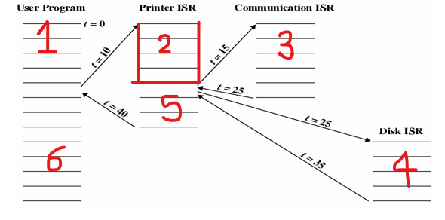**Q1: Calculate the time for each process, define the priority? Answer :**

The time for the following process :

User program T = 10

Printer ISR T = 10

Communication ISR T = 10

Disk ISR T = 10